

Reval ERP
HRMS – Employee Payslip

[Pre-LLD]
Low Level Design Document
Revalsys

REVISION HISTORY:

Version | Date Modified | Author | Reason for Change
1.0 | 16-04-2024 | Sivalatha | Pre LLD-Creation

This document has been reviewed and accepted:
Version | Date Reviewed | Reviewer Name | Title
1.0

Table of Contents
Table of Contents 3
1. Introduction: 4
1.1 Overview: 4
1.2 Purpose: 4
2. Scope Inclusion: 4
3. Standards, Conventions and Procedures:
3.1 Development Language: 6
3.2 Design/Programming Standards/Naming Conventions: 6
4. Screens / Functionalities / Validations: 6

Introduction:

Overview:
- This module can be accessible only after user logged in and logged in user must have the module permission.
- This module facilitates the user to view and generate the pay slip for chosen year and month of the user/employee.

Purpose:
- The purpose of this module is to implement the functionality for the actions below.
- User able to view the already generated pay slip of the user/employee.
- User able to generate the pay slip of the user/employee.

Scope Inclusion:

- When the user clicks on Pay Slip under HRMS Module in the side navigation menu, user will redirect to pay slip page.
- View the pay slip by clicking search button, if already generated, if not displayed error message is “No Payslip generated for the selected employee.”
- If pay slip available, displayed in the table format, in the table, employee Id, employee name, view, send email, checkbox for selecting employee.
- If user click on view icon, download the pay slip of respective user/employee.
- If user click on send mail icon, pay slip will send via mail to the respective user/employee.
- If user Selects multiple employees/users, then click on send mail button, pay slip will send via mail to be selected employees/users.
- To get the filter/search the employee, apply the filters as department, employee, year, and month, and click on search then display the employee with pay slip data if already generated.
- If click on generate button, generate the pay slips for selected employee(or)s or all employees.
- To generate pay slip for employee, apply the filters as department, employee, year, and month, and click on generate button, then generate the pay slip for the employee and display in the table.
- Note: Pay slips are exclusively generated for employees who have been assigned a salary template.

3. Standards, Conventions and Procedures:

3.1 Development Language:
Typescript, Angular 14.

3.2 Design/Programming Standards/Naming Conventions:
Camel case.

4. Screens / Functionalities / Validations:

- Pay slip Screen: Below is the sample screenshot for pay slip page we are developing, and once development is completed, we will keep the actual screen.
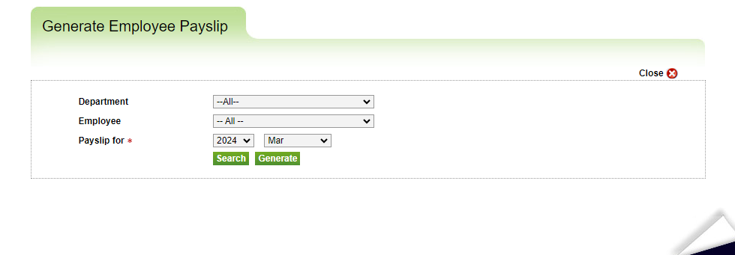
Pay slip Screen validation:

S. No | Fields | Description | Validations | Error Message
1 | Department (dropdown) | This field used for selecting the department. | - Non mandatory.  - By default, all selected.
2 | Employee  (dropdown) | This field used for selecting the employee. | - Non mandatory.  - By default, all selected.
3 | Year (dropdown) | This field used for selecting the year. | - Mandatory.  - By default, current year to be selected.  - Min year is 2020.  - Max year is current year. | - Required – Please select Year.
4 | Month (dropdown) | This field used for selecting the month. | - Mandatory.  - By default, previous month of current year will be selected.  - If year dropdown having current year, in month dropdown having previous month of current year.  - If year dropdown having previous years, in month year dropdown having all months.  Ex: Current year is 2024 and current month is April. If user select 2023 year, in month dropdown will bind all months. If user select 2024 year (current year), in month dropdown will bind until March (current month is April). | - Required – please select month.

- View the pay slip by clicking search button, list will be fetched from the GetPayslipBySearch API and displayed in a tabular format if already generated, if not displayed error message is “No Payslip generated for the selected employee.”
GetPayslipBySearch - To get payslip data.
URL | https://revalposapidev.revalweb.com/api/GetPayslipBySearch
Type | POST
Description | This API will used to get payslip data.
Request | {  "Code": "",  "Code1": "",  "Code2": "",  "Code3": "",  "SearchTypeId": "1",  "PageNumber": "1",  "PageSize": "10",  "CountryCode": "ind",  "CurrencyCode": "inr",  "LanguageCode": "eng"  }
Response | {  "ReturnCode": 0,  "ReturnMessage": "success",  "ResponseTime": "59",  "RecordCount": 8,  "Headers": [  {  "HeaderName": "HRMSEmployeeId",  "HeaderDisplayName": "Employee ID"  },  {  "HeaderName": "EmployeeName",  "HeaderDisplayName": "Employee Name"  },  {  "HeaderName": "FilePath",  "HeaderDisplayName": "View"  },  {  "HeaderName": "IsMailSent",  "HeaderDisplayName": "Send Email"  },  {  "HeaderName": "IsPublished",  "HeaderDisplayName": "Status"  },  {  "HeaderName": "CreatedBy",  "HeaderDisplayName": "Created By / Updated By"  },  {  "HeaderName": "DateCreated",  "HeaderDisplayName": "Date Created"  }  ],  "Data": [  {  "EmployeeID": "rer",  "EmployeeName": "anushan anushan",  "IsPublished": true,  "HRMSEmployeeId": "C7A97520-1595-47DF-9318-523786579162",  "HRMSEmployeePaySlipId": "01E189F1-85D8-4E57-A16B-86A67A50E02E",  "DepartmentId": "C65BFF2F-BAD0-47C8-9387-B4852E8C4365",  "DepartmentName": "Finance",  "FilePath": "https://imgklm01.revalweb.com/uploads/erpdevuploads/revalerplocal/reportfiles/generatedreports/a4982a7e-12d8-42cf-9fe9-42694fcb876d/anushan_pay_slip_march_2024.pdf",  "IsMailSent": false,  "DateFrom": "2024-03-01T00:00:00",  "DateTo": "2024-03-31T00:00:00",  "MonthNumber": 3,  "Year": 2024,  "FileGUID": "F3B1ED86-B70B-4413-A458-ADABFDC82271",  "FileName": "anushan_Pay_Slip_MARCH_2024.pdf",  "RowNumber": 1,  "RecordCount": 8  },  {  "EmployeeID": "RI 887",  "EmployeeName": "Upendra G",  "IsPublished": true,  "HRMSEmployeeId": "3F07A495-6DD4-4893-9E2C-8C6CB565FF6B",  "HRMSEmployeePaySlipId": "58D96DEB-1180-4E06-A481-8E5F537E0F2A",  "DepartmentId": "32A9928F-02AE-4B05-B678-0B0B25FD9BDB",  "DepartmentName": "Sales",  "FilePath": "https://imgklm01.revalweb.com/uploads/erpdevuploads/revalerplocal/reportfiles/generatedreports/e38928ed-cf58-4bb6-85fb-e010e9328790/upendra_pay_slip_march_2024.pdf",  "IsMailSent": false,  "DateFrom": "2024-03-01T00:00:00",  "DateTo": "2024-03-31T00:00:00",  "MonthNumber": 3,  "Year": 2024,  "FileGUID": "9F0DCCA8-2023-4FF2-9F2A-DB6DAA4B7278",  "FileName": "Upendra_Pay_Slip_MARCH_2024.pdf",  "RowNumber": 2,  "RecordCount": 8  },  ]  }

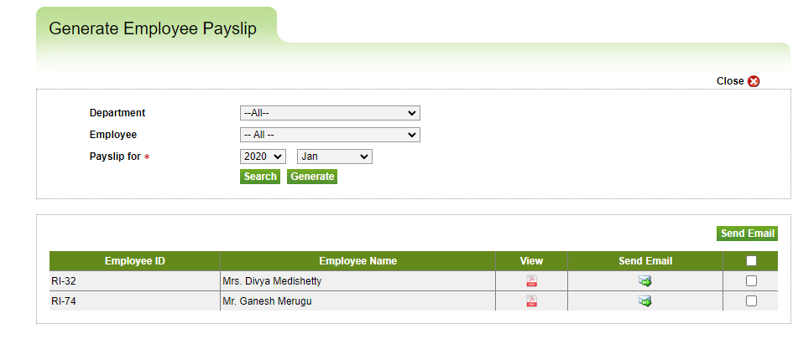
- If user click on view icon (pdf), will call DownloadPayslip API, then download the pay slip for view respective user/employee.
- DownloadPayslip - To get payslip data.
URL | https://revalposapidev.revalweb.com/api/DownloadPayslip
Type | POST
Description | This API will used to download payslip.
Request | {  "EmployeePayslipId":"01E189F1-85D8-4E57-A16B-86A67A50E02E",  "PayslipTypeId":"1"  }
Response | %PDF-1.4  %����  1 0 obj  <<  /Type /Catalog  /Pages 4 0 R  /MarkInfo<</Marked true>>  /Metadata 23 0 R  /OutputIntents 25 0 R  /StructTreeRoot 5 0 R  /PageMode /UseNone  >>  Endobj (Stream Data)

- If user click on send mail icon, pay slip will send via mail to the respective user/employee.
- If user selects multiple employees/users, then click on send mail button, pay slip will send via mail to the selected employees/users.
- To get the filtered/searched employee, apply the filters as department, employee, year, and month, and click on search then display the employee with pay slip data if already generated.
- If click on generate button, generate the pay slips for the selected employee(or)s or all employees.
- To generate pay slip for employee, apply the filters as department, employee, year, and month, and click on generate button, then generate the pay slip for the employee and display in the table.
- Note: Pay slips are exclusively generated for employees who have been assigned a salary template.

