

ERP
FINANCIAL ACCOUNTING MODULE
Accounting -Chart of Accounts
Requirements Specification
Revalsys

REVISION HISTORY:

Version | Date Modified | Author | Comments
1.0 | 26th June 2024 | Susheel Kumar | Creation
sVersion | Date Reviewed | Reviewer Name | Title
1.0 |  | Vinay | Reviewer
This document has been reviewed:

Version | Date Reviewed | Reviewer Name | Title
This document has been reviewed and accepted:

CONTENTS
CONTENTS 3
1. Introduction 4
2. Objectives 4
3. Scope 4
4. Functional Requirements 4
View & Creation of Account Type 4
View & Creation of Account Group Type 5
View & Creation of Ledger 5
View & Creation of Subledger 5
1 - Creation of Account Type 5
Epic 1.1 – View Screen for Account Type 5
Epic 1.2 – Add Account Type 6
2 - Creation of Account Group Type 7
Epic 2.1 – View Screen for Account Group Type 7
Epic 2.2 – Add Account Group Type 8

1. Introduction
The purpose of this document is to outline the business requirements for the Financial Account module, specifically focusing on the viewing and creation of Account Types, Account Group Types, Ledgers, and Subledgers. This module will facilitate efficient financial management and reporting within the organization.

2. Objectives
- To enable users to create and manage Account Types and Account Group Types.
- To provide functionalities for viewing and creating Ledgers and Subledgers.
- To ensure the system is user-friendly, secure, and scalable.

3. Scope
- Creation and management of Account Types.
- Creation and management of Account Group Types.
- Creation and management of Ledgers.
- Creation and management of Subledgers.
- User interface for viewing and managing financial accounts.

4. Functional Requirements

View & Creation of Account Type
- FR1.1: The system shall allow users to create new Account Types.
- FR1.2: The system shall display a list of existing Account Types.
- FR1.3: The system shall not allow users to edit existing Account Types.
- FR1.4: The system shall allow users to deactivate or delete Account Types.

View & Creation of Account Group Type
- FR2.1: The system shall allow users to create new Account Group Types.
- FR2.2: The system shall display a list of existing Account Group Types.
- FR2.3: The system shall not allow users to edit existing Account Group Types.
- FR2.4: The system shall allow users to deactivate or delete Account Group Types.

View & Creation of Ledger
- FR3.1: The system shall allow users to create new Ledgers.
- FR3.2: The system shall display a list of existing Ledgers.
- FR3.3: The system shall not allow users to edit existing Ledgers.
- FR3.4: The system shall allow users to deactivate or delete Ledgers.

View & Creation of Subledger
- FR4.1: The system shall allow users to create new Subledgers.
- FR4.2: The system shall display a list of existing Subledgers.
- FR4.3: The system shall not allow users to edit existing Subledgers.
- FR4.4: The system shall allow users to deactivate or delete Subledgers.

1 - Creation of Account Type

Epic 1.1 – View Screen for Account Type
User Stories
- As an User I should be able to add account type
- As an User I should be able to search account by name.
- As an User I should be able to set date range
- As an User I should be able to click on Submit button to get the data.
- As an User I should be able to manage the rows to show in data table per page.
- As an User I should be able to see the data table with account type, Code, Created by, status and actions.

SL No | Field Name | Mandatory | Input Type | Acceptance Criteria
1.1.1 | Add account type | N/A | Button | - When the user clicks the “Add Account Type” button, he should be redirected to the “Add New Account type” page.  - For the continue flow refer Epic 1.2
1.1.2 | Search by | N/A | Text Box | - Refer Standard BRD.  - The User can Search based on  - Account type name.
1.1.3 | Todate & From date | N/A | Date Picker | - Refer Standard BRD for To & From date validations
1.1.4 | Submit | N/A | Button | - Refer standard BRD.
1.1.5 | Show Entries | N/A | Drop down | - Refer Standard BRD.
1.1.6 | Table View | N/A | Grid View | - The user should be able to see account type, Code, Created by, status and actions in the table grid.  - Account Type – All the details should be fetched from Add Account Type Screen.  - Code – All the details should be fetched from Add Account Type Screen .  - Updated by – It should auto generated based on the user created the Account Type.  - Status - – All the details should be fetched from Add Account Type Screen.  - Actions – The action button should be there where the status can be changed from active to inactive / inactive to active position.

Epic 1.2 – Add Account Type
User Stories :-
- As an user I should be able to toggle between active and in active.
- As an user I should be able to enter Account type name
- As an user I should be able to enter Code
- As an user I should be able to click submit to save then data.
- As an user I should be able to cancel the recod.
SL No | Field Name | Mandatory | Input Type | Acceptance Criteria
1.2.1 | Status | Yes | Toggle button | - Refer Standard BRD.
1.2.2 | Account type | Yes | Text Box | - Users can enter only Alphabetical values.  - Users can’t use the same name user previously.  - Users can enter up to 64 Characteristics  - No special Characters are allowed.
1.2.3 | Code | N/A | Text Box | - Users can only enter numerical values.  - User can enter only one digit
1.2.4 | Savess | N/A | Button | - Refer standard BRD for Save button validations
1.2.5 | Cancel | N/A | Button | - Refer Standard BRD for Cancel button validations

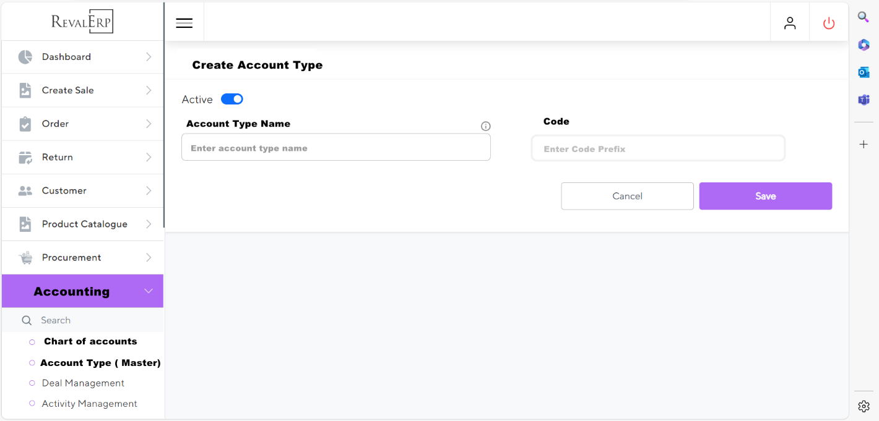

2 - Creation of Account Group Type

Epic 2.1 – View Screen for Account Group Type
User Stories
- As an User I should be able to add account Group type
- As an User I should be able to search by Account Type & Account Group Type name.
- As an User I should be able to set date range
- As an User I should be able to click on Submit button to get the data.
- As an User I should be able to manage the rows to show in data table per page.
- As an User I should be able to see the data table with Account Group Type, account type, Code, Created by, status and actions.
SL No | Field Name | Mandatory | Input Type | Acceptance Criteria
2.1.1 | Add account group type | N/A | Button | - When the user clicks the “Add Account Type” button, he should be redirected to the “Add New Account Group Type” page.  - For the continue flow refer Epic 2.2
2.1.2 | Search by | N/A | Text Box | - Refer Standard BRD.  - The User can Search based on  - Account type name.  - Account Group Type name.
2.1.3 | Todate & From date | N/A | Date Picker | - Refer Standard BRD for To & From date validations
2.1.4 | Submit | N/A | Button | - Refer standard BRD.
2.1.5 | Show Entries | N/A | Drop down | - Refer Standard BRD.
2.1.6 | Table View | N/A | Grid View | - The user should be able to see Account Group Type, account type, Code, Created by, status and actions in the table grid.  - Account Group Type – All the details should be fetched from Add Account Group Type Screen.  - Account Type – All the details should be fetched from Add Account Group Type Screen.  - Code – All the details should be fetched from Add Account Group Type Screen.  - Updated by – It should auto generate based on the user created the Account Type.  - Status - – All the details should be fetched from Add Account Group Type Screen.  - Actions – The action button should be there where the status can be changed from active to inactive / inactive to active position.

Epic 2.2 – Add Account Group Type
User Stories :-
- As an user I should be able to toggle between active and in active.
- As an user I should be able to select Account Type
- As an user I should be able to enter Account group type name
- As an user I should be able to enter Code
- As an user I should be able to click submit to save then data.
- As an user I should be able to cancel the record.
SL No | Field Name | Mandatory | Input Type | Acceptance Criteria
2.2.1 | Status | Yes | Toggle button | - Refer Standard BRD.
2.2.2 | Account type | Yes | Drop Down | - User should be able to select the account type from drop down.  - User can select only one value from drop down.  - All the values of drop down should be fetched from Account type master.
2.2.3 | Account group type | Yes | Text Box | - Users can enter only Alphabetical values.  - Users can’t use the same name user previously.  - Users can enter up to 64 Characteristics  - No special Characters are allowed.
2.2.4 | Code | N/A | Text Box | - Users can only enter numerical values.  - User can enter Two digit  - The prefix of the code should be based on the account type selected.
2.2.5 | Saves | N/A | Button | - Refer standard BRD for Save button validations
2.2.6 | Cancel | N/A | Button | - Refer Standard BRD for Cancel button validations

