New site Creation
Step 1: Browse the main site.
URL: Revalpos.revalerp.com
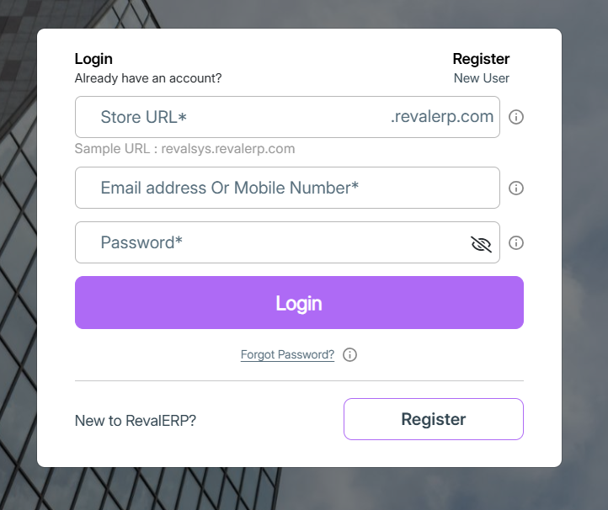
Step 2: Click on Register and provide the site details.
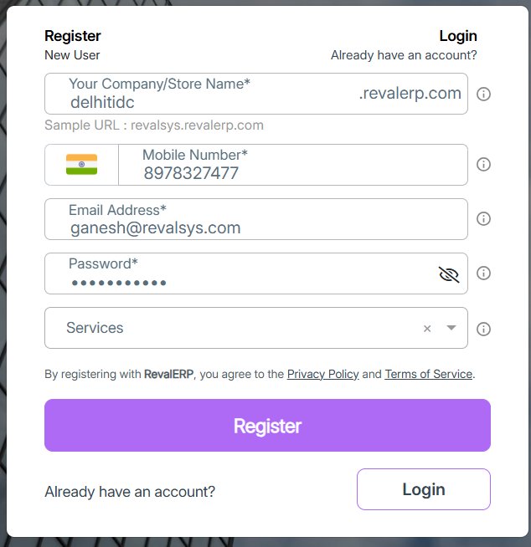

Step 3: Once click on Register button site will be created and redirected to that site.
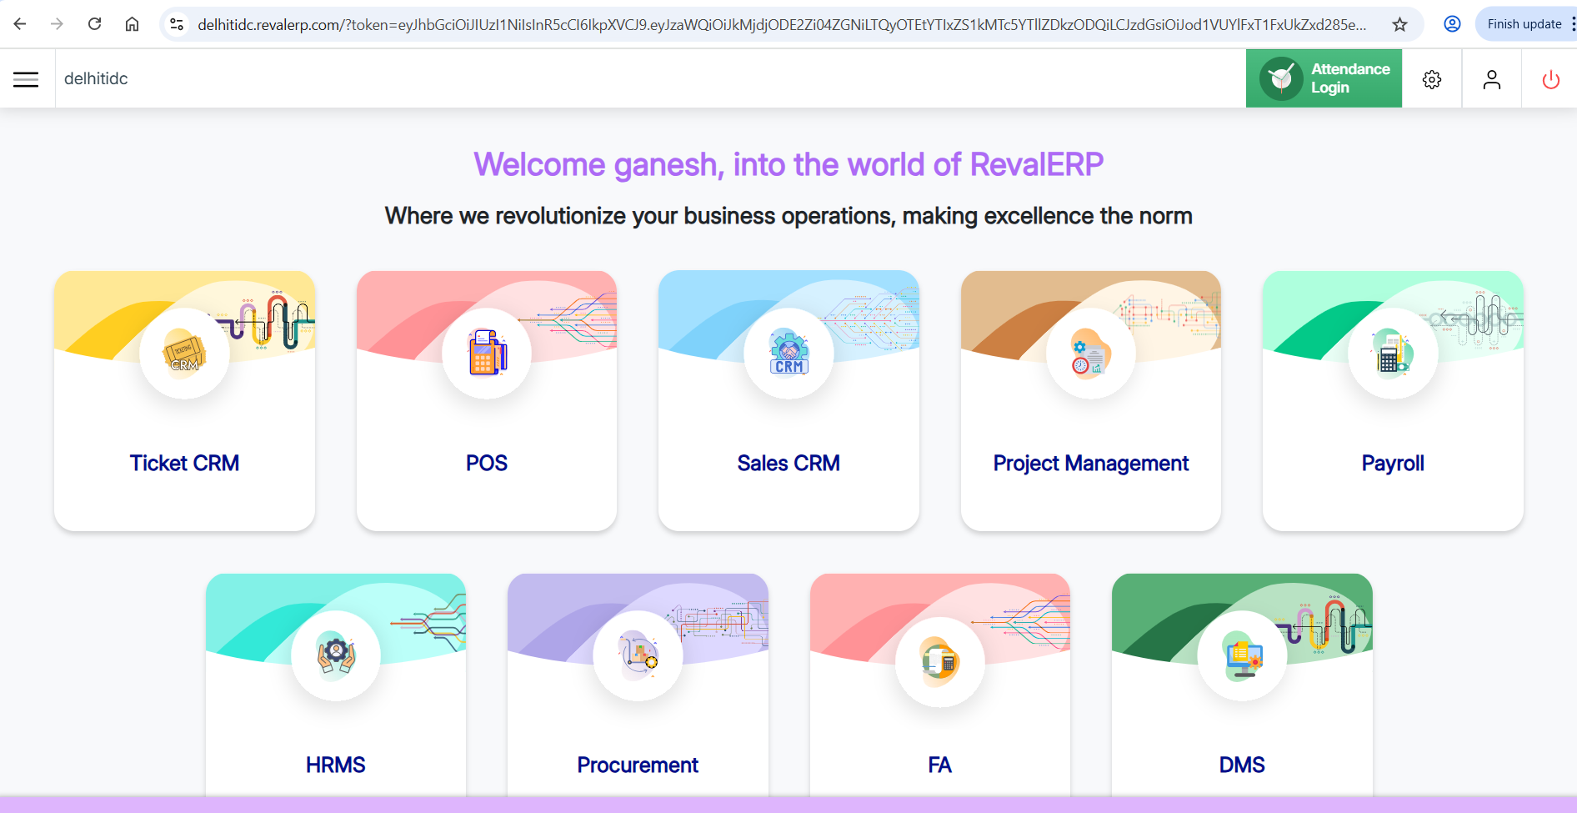
Step 4: Modify the subscription for this site. (If any doubts check with Vinod).
Provide the subscription for only the modules below,
- IOT Platform
- Ticket CRM
Step 5: Provide the required permissions.
IoT Platform -> Settings -> Role
Edit the required role to provide the permissions.
And then provide the permissions for Masters module for the “Admin” role.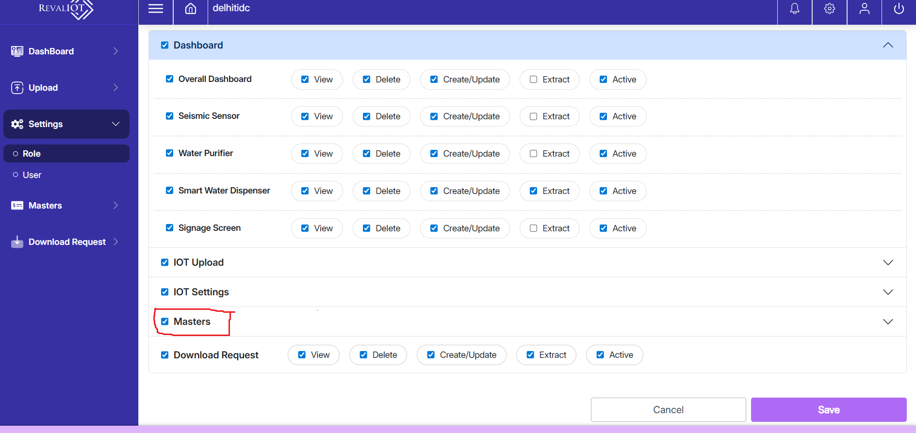
Step 6: Add the required Locations (shared by client) from Location module under Masters module.
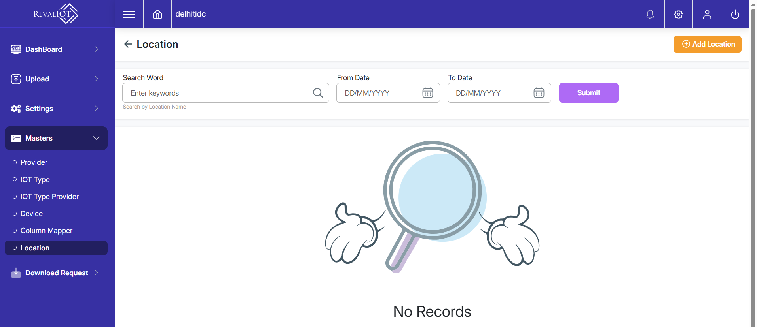

Step 7: Add the required Devices (shared by client) from Device module under Masters module.
