

HRMS - Leave Update Service
Revalsys

CONTENTS
CONTENTS 2
1. Introduction 3
2. Purpose 3
3. Scope 3
4. Service Overview 4
5. Functional Objectives 4
6. Execution Modes & Scheduler 4
7. Attendance Evaluation Rules 4
8. Leave Allocation Logic 5
9. Email Notification Framework 5
10. Conclusion 5

Introduction:
The HRMS Leave Update Service is an automated background module that evaluates employee login/logout activity to determine their daily attendance status. This system reduces dependency on manual attendance processing, enhances precision, and supports standardized implementation of leave policies across multiple sites and configurations.

- Purpose:
The fundamental purpose of this service is to automate the attendance reconciliation and leave adjustment process to ensure accurate payroll computation, operational efficiency, and policy compliance without human intervention.

Scope:
This service applies to all employees whose attendance is recorded through the HRMS system and automatically updates their leave and attendance status. It does not apply to employees or locations where attendance tracking is not enabled or not integrated with HRMS.

Service Overview:

The HRMS Leave Update Service evaluates employee activity for each working day and updates:

1. Full-Day Presence
2. Half-Day
3. Full-Day Leave
4. Loss of Pay (LOP)
5. Absent Without Intimation

It runs automatically based on system configuration and updates attendance records and leave balances accordingly.

Functional Objectives:

1. Automate attendance evaluation
2. Apply leave based on policy, template, and balance
3. Reduce manual corrections by HR
4. Eliminate payroll discrepancies
5. Enable transparent communication to employees and HR teams

- Execution Modes & Scheduler:
Execution Mode | Description
Daily Mode | • The service runs once every day at a fixed time.  • Example: 12:00 AM. For Previous day

Execution is conditional where:

It will run only if:
• The site has HRMS attendance module enabled.
• The site has turned on the Leave Update Service.
• The day is not a company holiday and Saturday & Sunday.

- Attendance Evaluation Rules:
Scenario | System Action and Email sent
Employee did not log in | Mark as Absent Without Intimation
Employee logged in but did not log out | Mark as Full-Day Leave
Employee worked less than minimum hours | Mark as Full-Day Leave
Employee worked more than minimum but less than Full required hours | Mark as Half-Day

These rules help the company keep accurate attendance even if the employee forgets to log in/out.

Scenario Descriptions:

1. Employee did not log in:
- Employee did not log in at all for the day.
- No leave request submitted in advance or Current date.
- System marks as: Absent Without Intimation / Full-Day Leave CL / LOP (Based on policy)

2. Login but No Logout:
- Employee logged in but did not log out by end of day.
- Indicates incomplete attendance.
- System marks as: Full-Day Leave

3. Worked Less Than Minimum Hours:
- Employee logged in and logged out but worked below minimum threshold (Ex: <3 hours)- Configurable from Master Module
- System marks as: Full-Day Leave

4. Worked Less Than Required Hours (But Above Minimum):
- Employee worked more than minimum but less than full-day required hours (Ex: 3–6 hours)- Configurable from Master Module

- System marks as: Half-Day Leave

Leave Allocation Logic:

Leave selection follows priority-based logic:
- Employee Leave Template
- Available Leave Balance
- Working Hours Evaluation
- If no leave available → Apply LOP

- Leave Carry Forward & Period Reset Logic:
The HRMS Leave Update Service supports automated leave balance carry forward and leave period reset mechanisms in accordance with the organization’s configured leave policies. This ensures accurate leave continuity, policy compliance, and zero manual intervention by HR.

9.1 Leave Carry Forward Processing (Monthly & Yearly):
- At the start of each new month or leave cycle, the service evaluates the remaining leave balance from the previous period.
- Any eligible unused leave is carried forward and added to the newly allocated leave for the current month or year, in accordance with the employee’s configured leave template.
- The updated leave balance becomes immediately available for leave allocation and attendance reconciliation.
Monthly Carry Forward Example:
- Previous month remaining leave balance: 1.5 days
- Current month leave allocation: 1.5 days
- Total available leave for the current month: 3.0 days
Yearly Carry Forward Behavior:
Eligible unused leave from the previous year is carried forward as per policy configuration.
- New annual leave allocations are then applied.
Yearly Carry Forward Example:
- Previous year remaining leave balance: 5.0 days
- New year leave allocation: 12.0 days
- Total available leave for the new year: 17.0 days
This mechanism ensures continuity of eligible leave balances while maintaining strict compliance with organizational leave policies and statutory requirements.

9.3 Key Benefits:
- Automated monthly and yearly leave carry forward
- Accurate and compliant leave period resets
- Elimination of manual HR reconciliation
- Improved payroll accuracy and governance
- Transparent and auditable leave balance computation

Email Notification Framework:

Notifications are triggered for:
- Absent Without Intimation
- Login But Not LogOut
- Working Less Than minimum Hours
- Working Less Than Maximum Hours

Recipients:
- Employee
- HR Team (If enabled)
- Additional CC (Configured per site)
Purpose:
- Governance
- Transparency
- Payroll processing
- Employee accountability

Email Trigger Screenshots: 🖼️

- Login But Not Logout Email Template: You logged in but did not log out. As per policy, this is treated as a full-day leave. If this is a mistake, please contact HR.

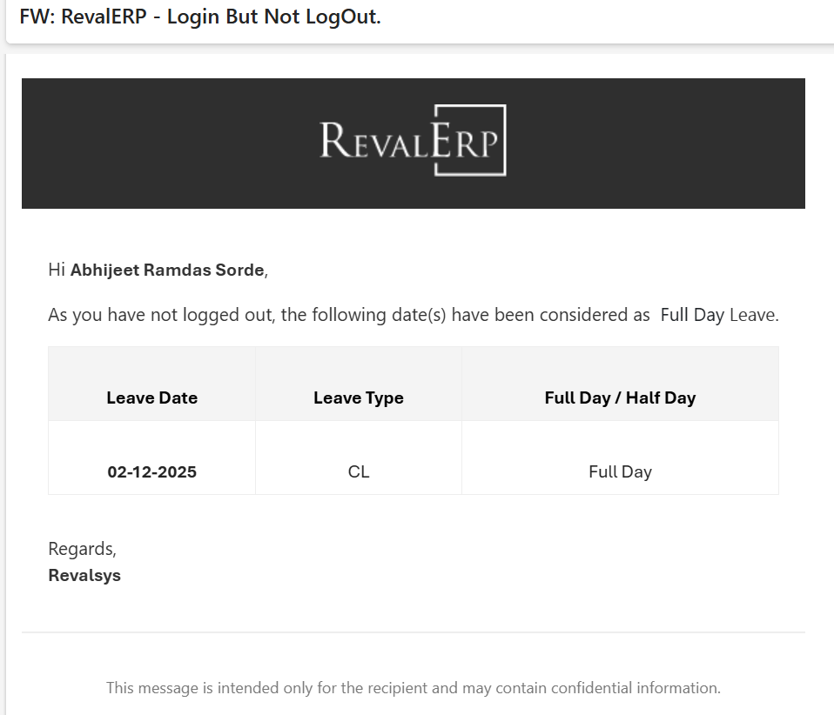

- Full Day Absent Without Intimation: The employee did not log in at all, and there was no leave request submitted.

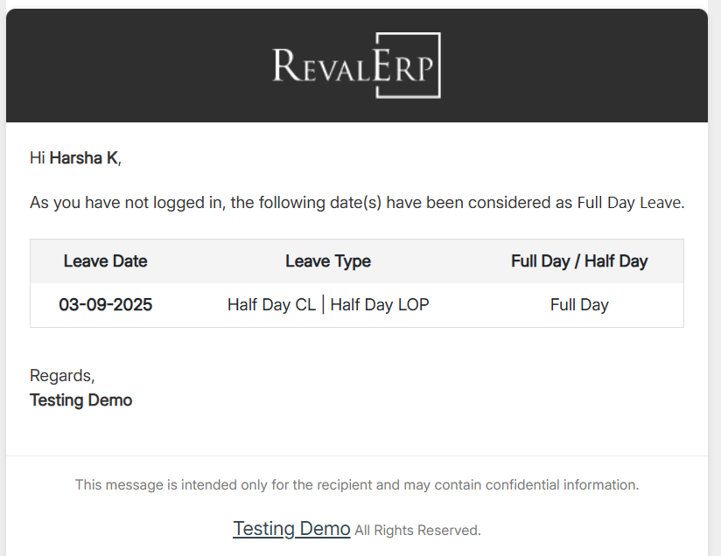

- Working Less than 3 Hours: The employee logged in and logged out, but worked less than the minimum required 3 hours.

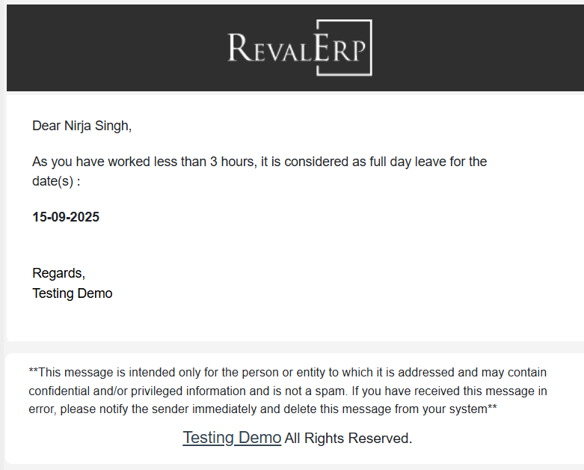

- Working Less than 6 Hours: The employee worked more than 3 hours but less than 6 hours.

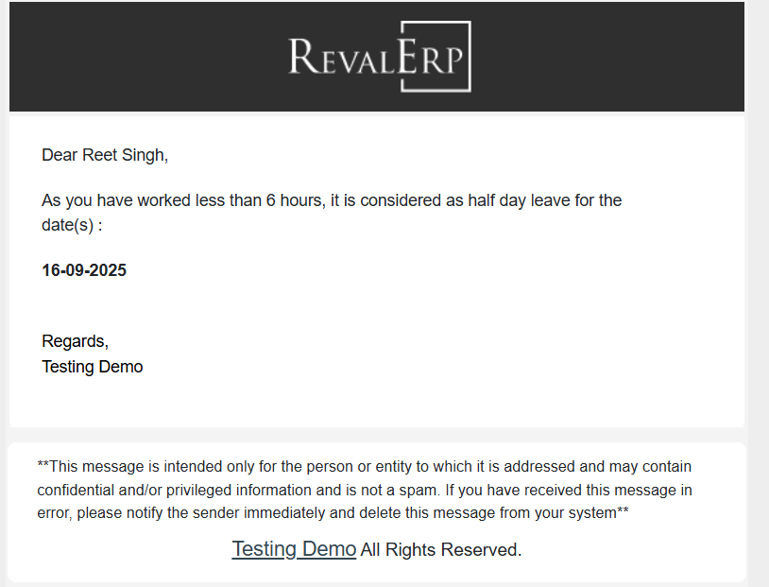

17. Conclusion:
The HRMS Leave Update Service standardizes attendance management, minimizes HR workloads, improves governance, and ensures fair and automated application of policies.

