

Reval ERP
Code Review Tool: Best Practices and Standards
(Functional)

REVISION HISTORY:

Version | Date Modified | Authors | Comments
1.0 | 01 April 2025 | Naresh | Creation
Version | Date Reviewed | Reviewer Name | Title
1.0 | 01 Apr 2025 | Swamy | Development of standard code review tool document review.
This document has been reviewed:

Version | Date Reviewed | Reviewer Name | Title
1.0 |  |  | Reviewed & approved
This document has been reviewed and accepted:

Table of Contents
Definition 4
Purpose 4
Functional Requirements - Code Review Categories 4
Standardized Code Checks 4
Code Complexity Detection 4
Performance Optimization Checks 5
Handling Exceptions 5
Documentation Best Practices 5
Safe List Usage 5
Best Practices 5
Dead Code 6
Code Review Reports 6
Best Practices for Effective Code Reviews 6
Ensure Thorough Review 6
Continuous Improvement 6
Team Consistency 6
Reval Code Reviewer plug-in installation 7
Step 1: Check Visual Studio Version 7
Step 2: Install the VSIX Extension 7
Step 3: Restart Visual Studio 7
Step 4: Open the Project Solution 7
Step 5: Conduct a Code Review 7
Step 6: Review Completion Notification 7
Step 7: View Code Review Report 8

Definition
The Code Review Tool is a powerful platform designed to assist teams in ensuring adherence to coding standards and best practices as defined by the company, during the software development process. This tool automates the inspection of code, providing insights and suggestions to help developers write clean, efficient, and maintainable code.

Purpose
The primary purpose of the Code Review Tool is to:
- Ensure adherence to established coding standards and best practices.
- Improve code quality by detecting issues early in the development process.
- Reduce human error and inconsistency in code reviews.
- Speed up the review process by automating repetitive tasks.
- Provide actionable feedback for developers to enhance code maintainability, performance, and security.

Functional Requirements - Code Review Categories

Standardized Code Checks
  - Enforces the adherence to naming conventions, indentation, and method structure as defined in the coding standards.
  - Reviews code for common performance optimizations such as catching, asynchronous programming, and serialization methods.

Code Complexity Detection
  - Identifies overly complex methods and suggests refactoring opportunities to improve readability and maintainability.
  - Ensures methods are no longer than 25 lines and follow the single responsibility principle.

Performance Optimization Checks
  - Flags potential performance bottlenecks, including redundant database queries, improper caching usage, and inefficient serialization.
  - Offers suggestions to implement server-side caching, compression, and optimized serialization.

Handling Exceptions
  - Ensure that exceptions are logged properly, and rethrows exceptions with the original stack trace preserved.
  - Flags code that swallows exceptions without logging and suggests using custom exception classes for more specific error handling.

Documentation Best Practices
  - Ensures that all code is properly documented with clear comments, especially for complex algorithms or functions.
  - Validates that code includes summaries for methods, classes, and properties, adhering to structured commenting formats.

Safe List Usage
  - Ensures safe usage of lists, especially with regard to null values or potential IndexOutOfRangeException.
  - Suggests checking list bounds before accessing elements or using safer methods like FirstOrDefault() for retrieving elements.
  - Flags lists that can be replaced with more efficient data structures when performance is critical.

Best Practices
  - Encourages the use of industry-wide best practices, such as writing clean and maintainable code
  - Ensures proper error handling, logging, and exception management.
  - Enforces the use of dependency injection, modular architecture, and separation of concerns.
  - Validates code consistency across teams with well-defined coding guidelines for naming conventions, class design, and other coding standards.

Dead Code
  - Identifies unused variables, methods, classes, and other code that are no longer in use.
  - Recommends removing dead code to improve readability, reduce maintenance cost, and minimize the potential for errors.
  - Flags commented-out code that should either be removed or properly explained if it's temporarily disabled.

Code Review Reports
The tool generates detailed reports on each pull request, summarizing the following:
- Number of Issues: Displays the total number of issues found in the code, categorized by severity (critical, major, minor).
- Suggestions for Improvement: Provides actionable suggestions for each flagged issue, including code snippets to fix the problems.
- Compliance Score: A score that indicates how well the code adheres to the established standards.

Best Practices for Effective Code Reviews

Ensure Thorough Review
  - Developers should actively engage with the feedback provided by the tool, addressing each issue before requesting a final review.

Continuous Improvement
  - Code reviews are not just about identifying problems, they are opportunities for learning. Developers should use the tool’s suggestions to enhance their skills and improve the overall codebase.

Team Consistency
  - Ensure all team members follow the same standards and encourage collaboration during code review discussions to reach consensus on code improvements.

Reval Code Reviewer plug-in installation

Step 1: Check Visual Studio Version
Ensure that your Visual Studio 2022 version is 17.10.0 or above.

Step 2: Install the VSIX Extension
- Navigate to the provided path:
\\172.22.8.124\LiveRevalweb\VisualStudio_extensions\Reval Code reviewer\VSExtesnion.vsix
- Copy the above extension file into the local machine and then run it.
- 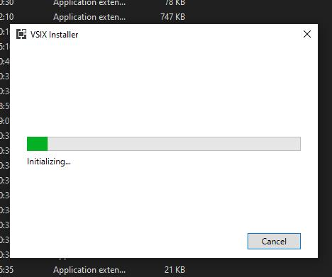

- Install the .vsix file with admin privileges.

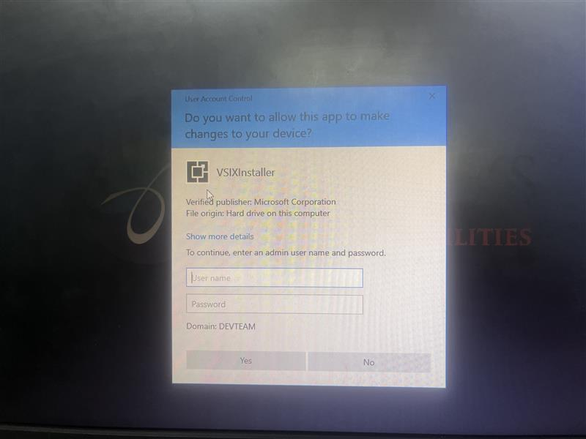

Step 3: Restart Visual Studio
- After the installation is complete, restart Visual Studio if it is already open.

Step 4: Open the Project Solution
- Launch your project solution in Visual Studio.
- Under the Tools menu, locate Reval Code Reviewer.
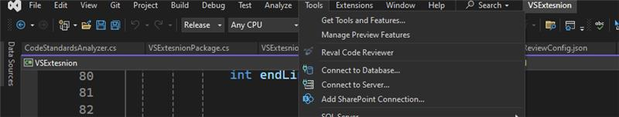

Step 5: Conduct a Code Review
- Open the file you want to review.
- Perform the code review using Reval Code Reviewer.

Step 6: Review Completion Notification
Once the review is completed, a popup will appear stating:
"Code review has been done, report generated successfully."
- A View Report button will be available.

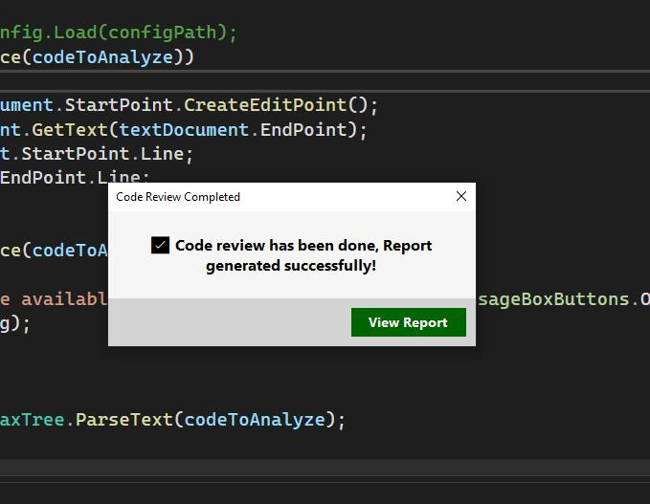

Step 7: View Code Review Report
- Click the View Report button.
- The code review report will open in your default web browser.

