

ONDC-Seller APP
On-Seach API Development

Low Level Design Document
Revalsys

REVISION HISTORY:

Version | Date Modified | Author | Reason for Change
1.0 | 22-10-2023 | Akhila R | Creation

This document has been reviewed and accepted:
Version | Date Reviewed | Reviewer Name | Title
1.0

CONTENTS
CONTENTS 3
1. Introduction: 4
1.1 Overview: 4
1.2 Purpose: 4
Existing system: 4
Proposal system: 4
2. Context Diagram (High –Level approach): 5
2.1 Current Context (in-case of re-engineering project): 5
3.2 Context diagrams: 5
3. Standards, Conventions and Procedures: 5
4.1 Development Language: 5
4.2 Design/Programming Standards/Naming Conventions: 5
4.3 Authentication Mechanism: 5
4.4 Exception Handling/Logging: 5
4.5 Session Management: 5
4.6 Database Calls: 6
4.7 Configuration Parameters: 6
5. Framework Components: 6
6. Database: 6
6.1 Database schema: 6
6.2 Data Tables: 6
6.3 Table Structure: 6
7. Screen/ETL Design 7
7.1 Screens: 7
7.2. Business Components: 7
8. Methods: 8
9. Validations: 15
10. Request & Response Methods: 15
11. Stored Procedutres: 15

Introduction:

Overview:
The main overview of this document is to implement the on_search API for V1.2 changes in ONDC seller App. This API will get the product details based on search word.

Purpose:
This API will get the product details based on search word.

Existing system:
NA

Proposal system:
In the Proposal System,doing the changes as per ONDC V1.2 Version.
- If the user selects the product in ONDC buyer app select api will call and send the response to on_select api.
- The response of on_select api will give the response to init api as request.
- First, we are validating the ONDCTransactionId Existed or not in our system. If ONDCTransactionId not existed thorough an error, if it is existed then return the IsTransactionIdExists as true. Then we are getting the StoreBasketDetails based on transactionid (given from on_select api).
- Then validating the BillingInfo , here we will get the username, mobile and email. Based on these fields getting the customer details from Db. If customer not existed inserting the new user.
- Then validating the Fulfilments details , here we will inserting the shipping address to customer in tblAddress.
- Then check the order status then, GetAddressByIdDB here getting the address details based on the address id.
- GetMakePaymentDetails here getting the payment and order details based on the BaketGuid,AddressGUID and BillingAddressGuid.
- GetTotalOrderValueForCartV2 here get the total value for the present cart.
- Then calling the GenerateStoreOrder to initialize the order in respective site.

2. Context Diagram (High –Level approach):

2.1 Current Context (in-case of re-engineering project):
NA

2.2 Context diagrams:
NA

3. Standards, Conventions and Procedures:

3.1 Development Language:
Microsoft C# .NET 5.0

3.2 Design/Programming Standards/Naming Conventions:
\\revalserv\JockeyIndia.revalweb.com\Documents\Guidelines to developers

3.3 Authentication Mechanism:
NA

3.4 Exception Handling/Logging:
3.4.1 Unhandled exception logging
Based on configuration, the exception handling is done and the exception is stored in a Database.
3.4.2 Handled exception logging:
Based on configuration, the exception handling is done and the exception is stored in a Database.
3.4.3 General logging:
Based on configuration, the exception handling is done and the exception is stored in a Database.
3.4. 4 Displaying Error Messages to Users:
User friendly messages are displayed.

3.5 Session Management:
In process session for ASP.Net screens.

3.6 Database Calls:
This is done using the ADO.Net

3.7 Configuration Parameters:

<ConnectionStrings>
<add name="ConnectionString" connectionString="Data Source=192.168.1.150; Initial Catalog=Revalweb; Persist Security Info=True; User ID=developers; Password=Password:; MultipleActiveResultSets=False;
Packet Size=4096; Application Name=&quot; Revalweb_Jockey2013&quot;" provider Name="System.Data.SqlClient" />
</ConnectionStrings>

4. Framework Components:
Used Microsoft .NET Framework 4.5.2

5. Database:

5.1 Database schema:

- usp_ONDC_CheckTransactionIdExistsOrNot: This procedure is used to check transaction id existed or not. This is new procedure.

- usp_ONDC_GetAllSiteDetails: This procedure is used to get all the site details. It is new procedure.

- usp_ONDC_GetSiteConfigOptionsBySiteConfigId: This procedure is used to get all the site config option details. It is a new procedure.

- usp_ONDC_GetLanguageCode : This procedure is used to get all the language details. It is a new procedure.

- usp_ONDC_GetStoreBasketDetailsByONDCTransactionId : This procedure is used to get all the language details. It is a new procedure.

- usp_ONDC_GetAddressById : This procedure is used to get all the address details by id. It is a new procedure.

- usp_ONDC_GenerateStoreOrder: This procedure is used Create the order. It is a new procedure.

- usp_ONDC_CheckStockAvailable: This procedure is used Check the stock available or not. It is a new procedure.

- usp_ONDC_GetStoreCustomerDetailsByEmail: This procedure is used Check the store customer details available or not, if it is not available then insert in new user. It is a new procedure.

- usp_ONDC_GetTotalCartDetails: This procedure is used to get the cart details. It is a new procedure.

- usp_ONDC_UpdateStandardDeliveryDateByCartItem : This procedure is used to update the Delivery date by CartItem. It is a new procedure.

- usp_ONDC_GetCurrencyDetailsByCurrencyId: This procedure is used to get the currency details by date by Currency Id. It is a new procedure.

- usp_ONDC_GetAllCurrencyDetails: This procedure is used to get the currency details by Currency Id. It is a new procedure.

- usp_ONDC_UpdateTotalOrderValueForCartV2 : This procedure is used to update the order details. It is a new procedure.

- usp_ONDC_GetErrorCode : This procedure is used to get the error code details. It is a existing procedure.

- usp_ONDC_GetMakePaymentDetails : This procedure is used to get the payment details. It is a new procedure.

5.2 Data Tables:

NA

5.3 Table Structure:

NA

6. Screen/ETL Design

6.1 Screens:

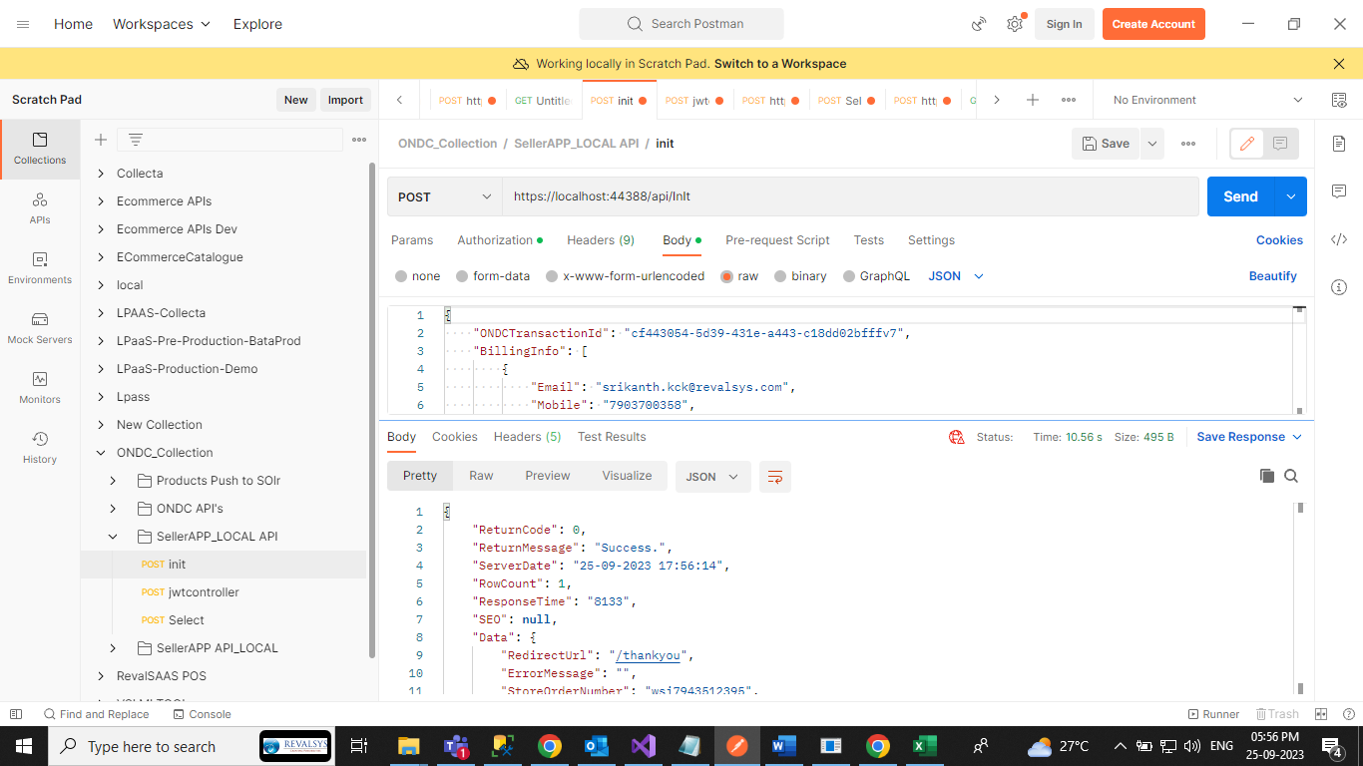
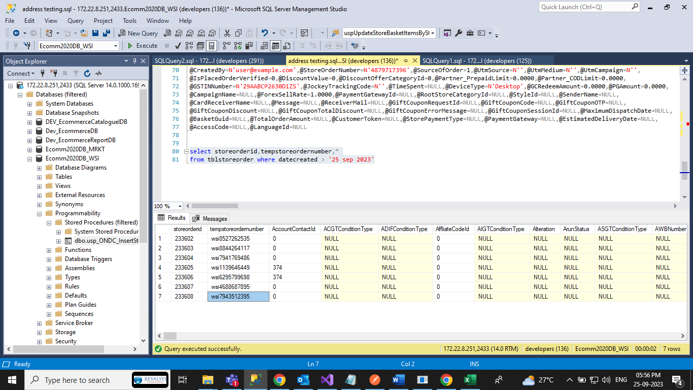

6.2. Business Components:

Controllers:

- InItController.cs

NameSpaces:
- Revalsys.Properties_ONDC
- Revalsys.BusinessLogic_ONDC
- Revalsys.DataAccess_ONDC
- Revalsys.Secuirty_ONDC
- Revalsys.TimeZone_ONDC
- Revalsys.Common_ONDC

8. Methods:

Modification:
- InitializeOrder ():
Method name | InitializeOrder ()
Purpose | This method is used to InitializeOrder.
Functional Parameters | objAPIRequest
Pseudo Code | It will check the validations for ONDCTransactionId and Billing Information. Then no validation error is fire Order is created.

- CheckOrderStatus():
Method name | CheckOrderStatus ()
Purpose | This method is used to check the order status.
Functional Parameters | StoreOrderId, StoreOrderStatusId
Pseudo Code | It will check the Order Status based on StoreOrderId, StoreOrderStatusId.

- BindTotalPriceNew():
Method name | BindTotalPriceNew ()
Purpose | This method is used to Bind the Price of cart item.
Functional Parameters | StoreOrderId, StoreOrderStatusId
Pseudo Code | It will check the Order Status based on StoreOrderId, StoreOrderStatusId.

- CheckServiceability ():
Method name | CheckServiceability ()
Purpose | This method is used to check the Serviceability for the pincode.
Functional Parameters | Pincode
Pseudo Code | It will check the Serviceability for the Pincode.

- GenerateStoreOrder():
Method name | GenerateStoreOrder ()
Purpose | This method is used to Generate the Order.
Functional Parameters | int intPaymentGateWayId, int PaymentTypeId, string strCouponCode, string strIPAddress, string BasketGuid, string CustomerToken, decimal ForexSellRate, string strCurrencyCode, int intStorePaymentGroupId, List<StoreCustomerDetail> lstStoreCustomerDetail,Int64 intLanguageId ,int paymentCurrencyId = 1, string strUserAgent = ""
Pseudo Code | It is used to Generate the Order.

- UpdateStoreOrderDetails():
Method name | UpdateStoreOrderDetails ()
Purpose | This method is used to update the Order details to paid.
Functional Parameters | int StoreOrderStatusId, string strStoreOrderStatus, string strAWBNumber, string strIPAddress, string strTransactionId, List<StoreCustomerDetail> lstStoreCustomerDetail
Pseudo Code | This method is used to update the Order details to paid.

Request :

{
"ONDCTransactionId": "cf443054-5d39-431e-a443-c18dd02bfffv7",
"BillingInfo": [
{
"Email": "srikanth.kck@revalsys.com",
"Mobile": "7903700358",
"UserName": "srikanth.kck@revalsys.com"
}
],
"paymenttype": "cod",
"fulfillment": [
{
"type": "home-delivery",
"tracking": false,
"start": {
"location": {
"id": "./retail.kirana/ind.blr/pooja-stores.koramangala-4th-block@lrdn.bpp.shopez.com.provider_location",
"descriptor": {
"name": "Pooja Stores"
},
"gps": "12.9349377,77.6055586"
},
"time": {
"range": {
"start": "2021-06-15T07:09:30.000Z",
"end": "2021-06-15T07:10:30.000Z"
}
},
"instructions": {
"name": "pick up instructions",
"short_desc": "Provide the order id"
},
"contact": {
"phone": "+919999999999",
"email": "info@poojastores.com"
}
},
"end": {
"location": {
"gps": "12.914028, 77.638698",
"address": {
"door": "21A",
"name": "ABC Apartments",
"locality": "HSR Layout",
"city": "Bengaluru",
"state": "Karnataka",
"country": "India",
"area_code": "500034"
}
},
"time": {
"range": {
"start": "2021-06-15T07:11:36.212Z",
"end": "2021-06-15T07:12:36.212Z"
}
},
"instructions": {
"name": "drop off instructions",
"short_desc": "Leave at door step"
},
"contact": {
"phone": "+919876543210",
"email": "user@example.com"
}
}
}
]
}

Response:

{
"ReturnCode": 0,
"ReturnMessage": "Success.",
"ServerDate": "04-09-2023 10:10:03",
"RowCount": 1,
"ResponseTime": "30735",
"Data": {
"RedirectUrl": "/thankyou",
"ErrorMessage": "",
"StoreOrderNumber": "wsi3424181226",
"PaymentGateWay": null,
"Cards": null,
"IsGiftCardApplied": false,
"IsValidGiftCoupon": false
}
}

9. Validations:

- SecurityToken required for both the methods.
- If the definition is not defined based on Payment method and payment gateway, then existing flow should follow.

