https://foservices.icegate.gov.in/#/login
Login to New ICEGATE website
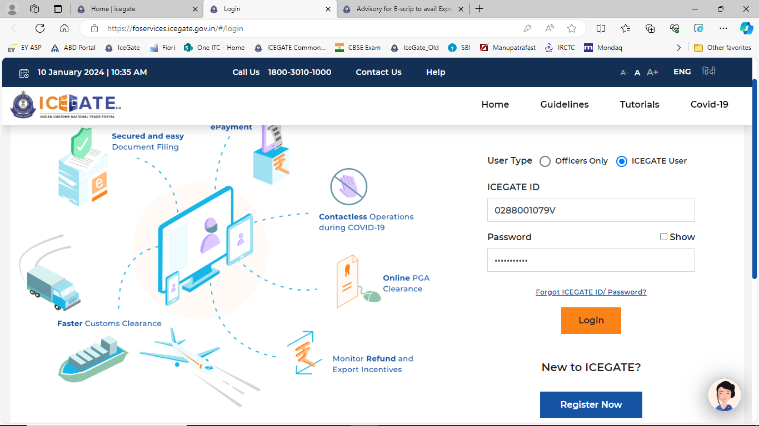

Click on “Services”
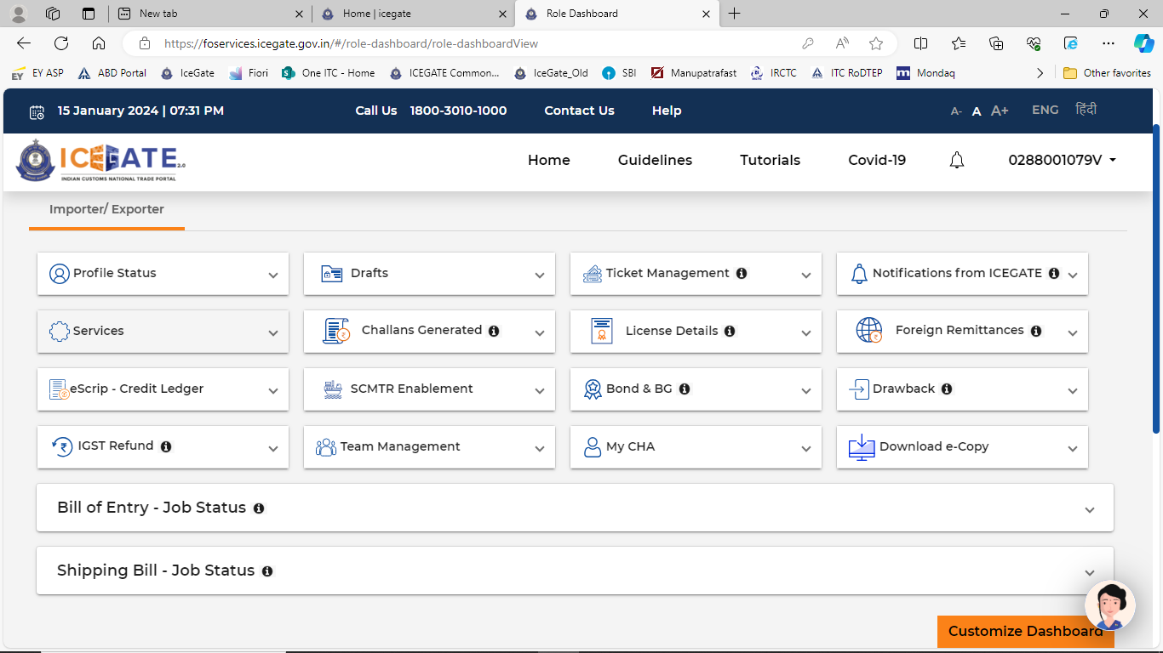

Click on “E-Payment” > button
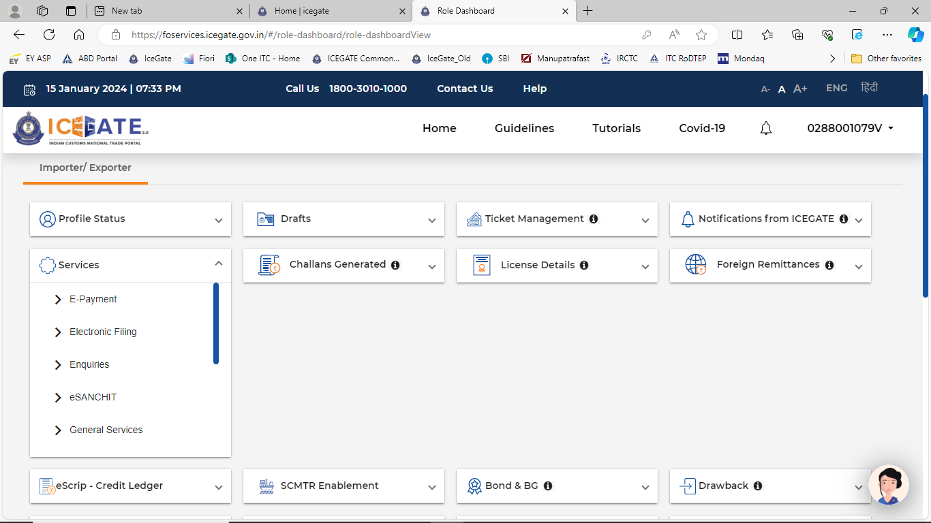

Click on “ECL Duty Payment”
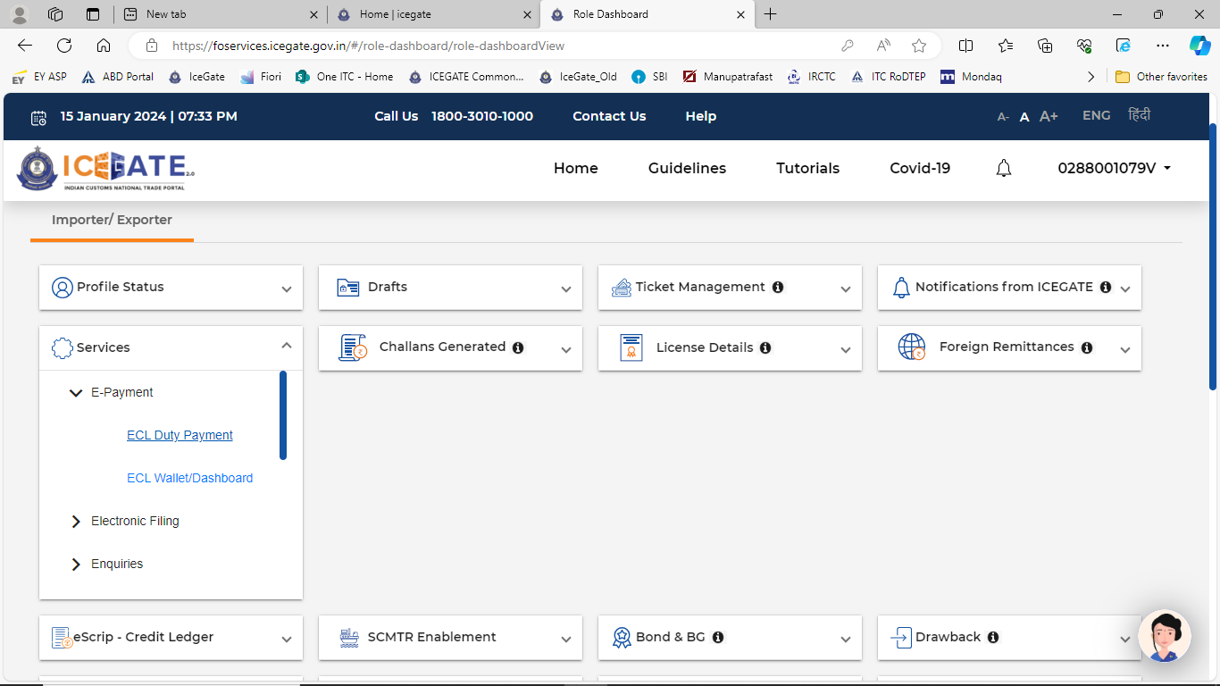

Select “BE” or “SB” based on the request by the user
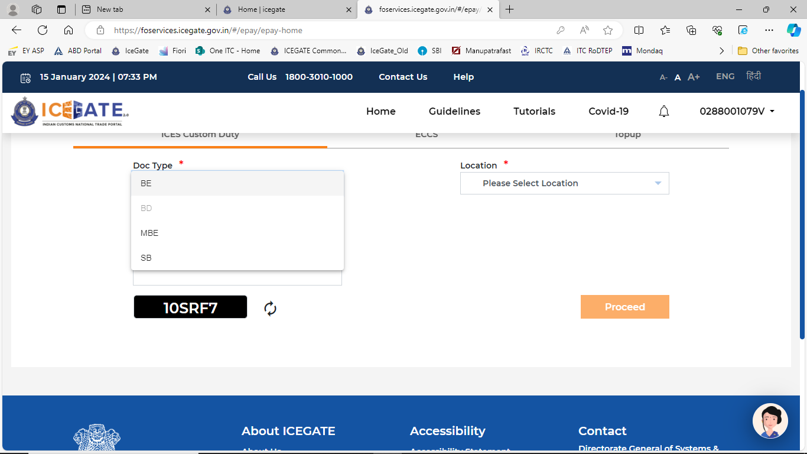
Fill identification number as “0288001079”
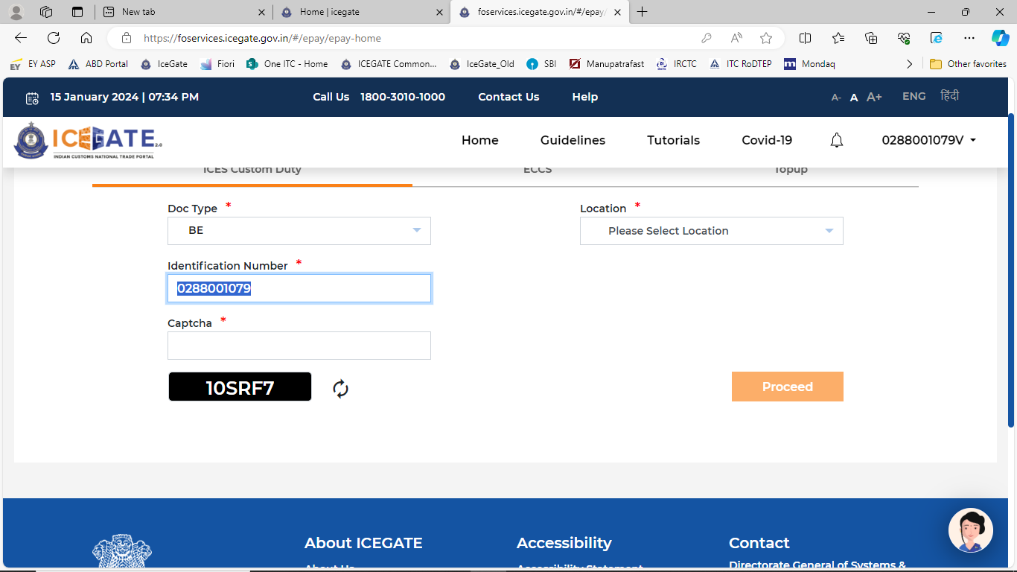

Enter Captcha
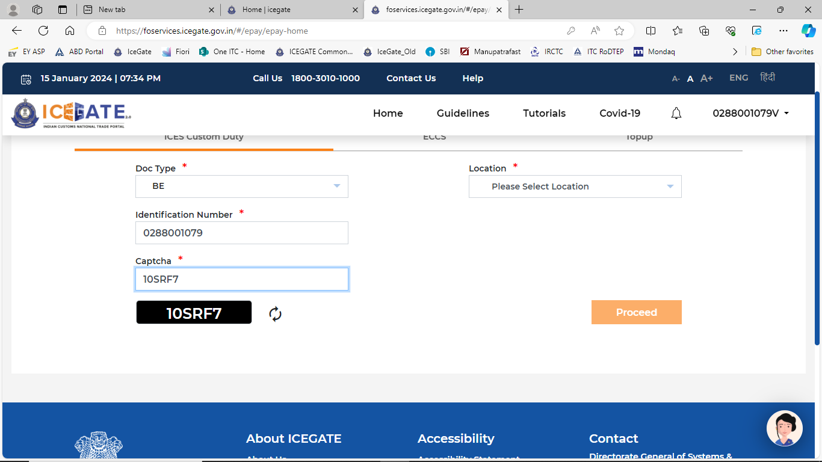
Select the location as per the request by user and click on “Proceed”
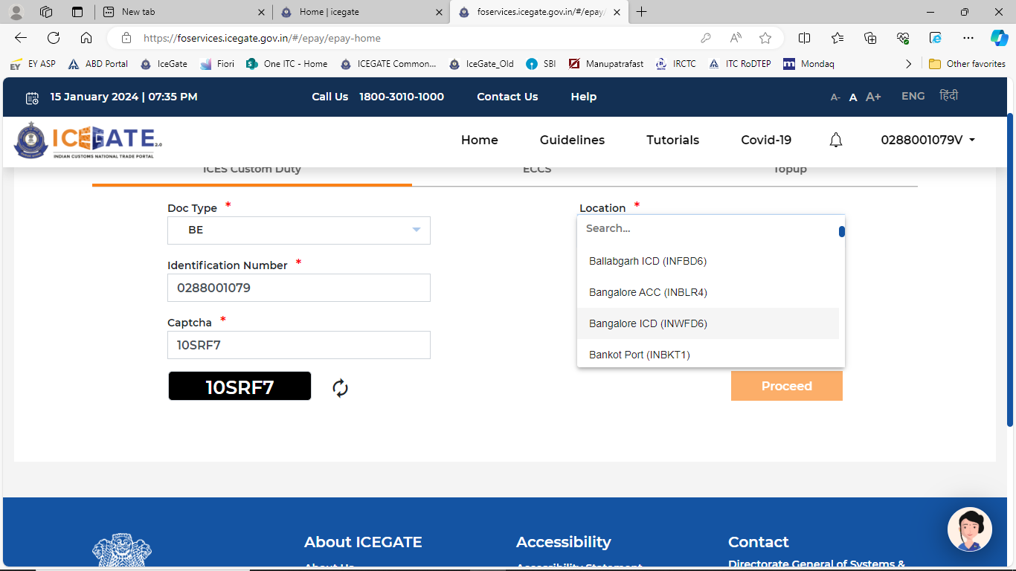

System displays all the unpaid challans
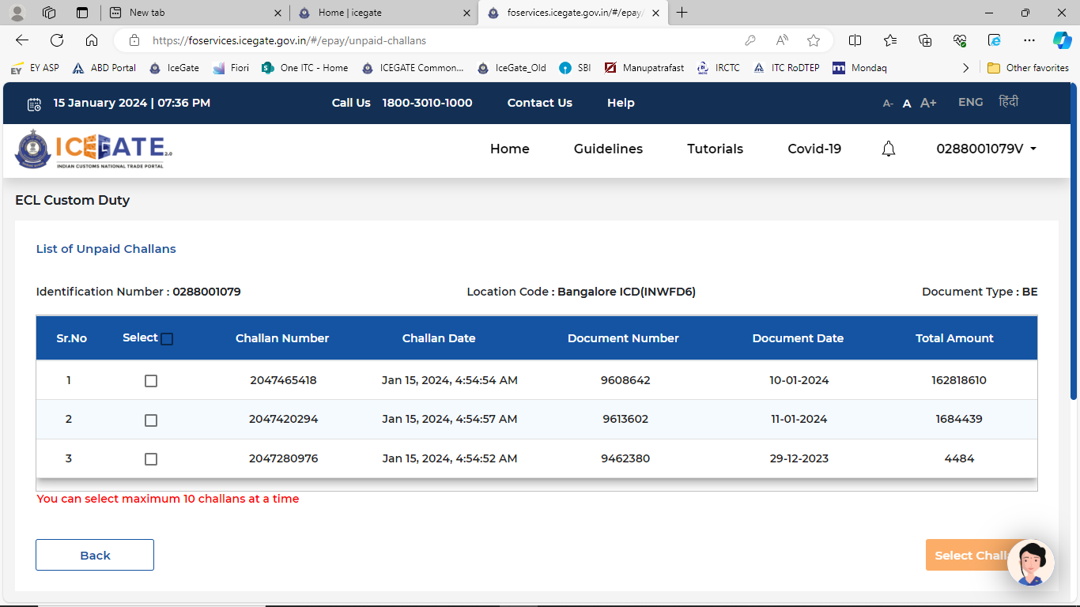
Select appropriate challan as requested by the user and press “Select Challan” button.
Capture the “challan number” into RoDTEP system
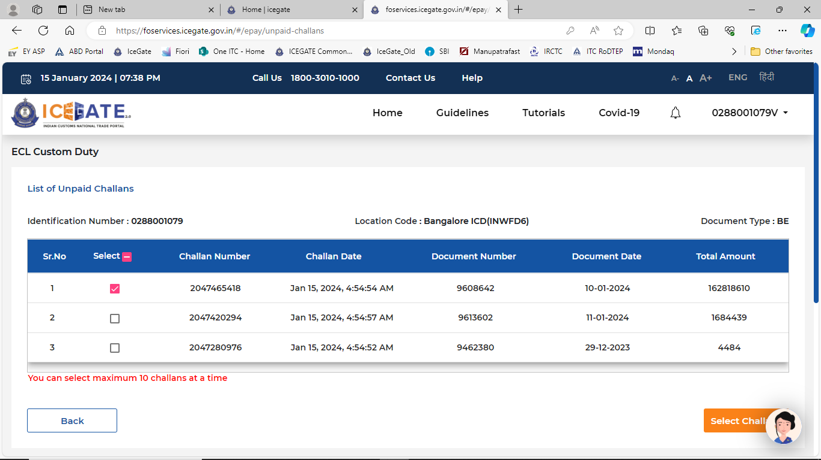

Press “Proceed for Payment”
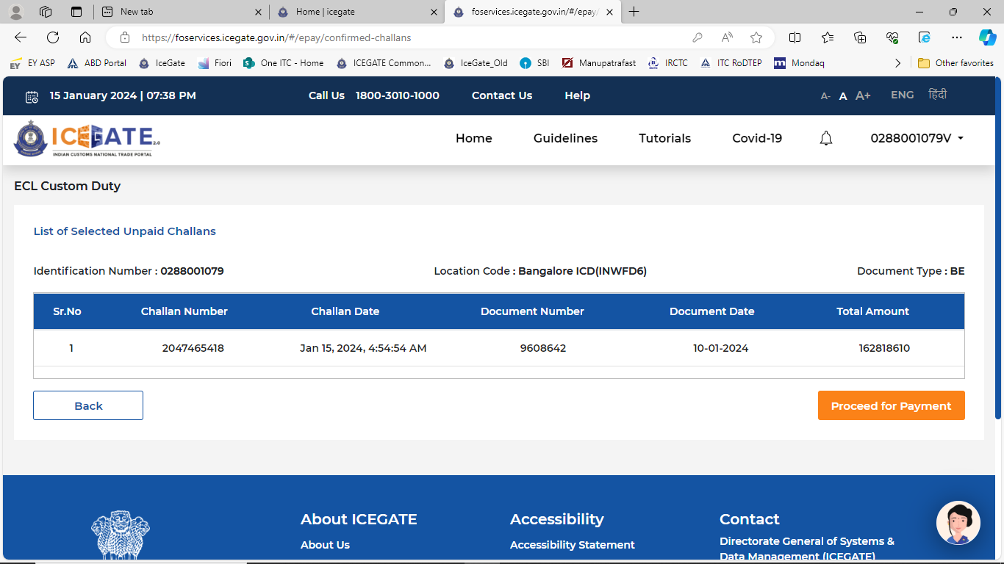
Select “Net Banking”
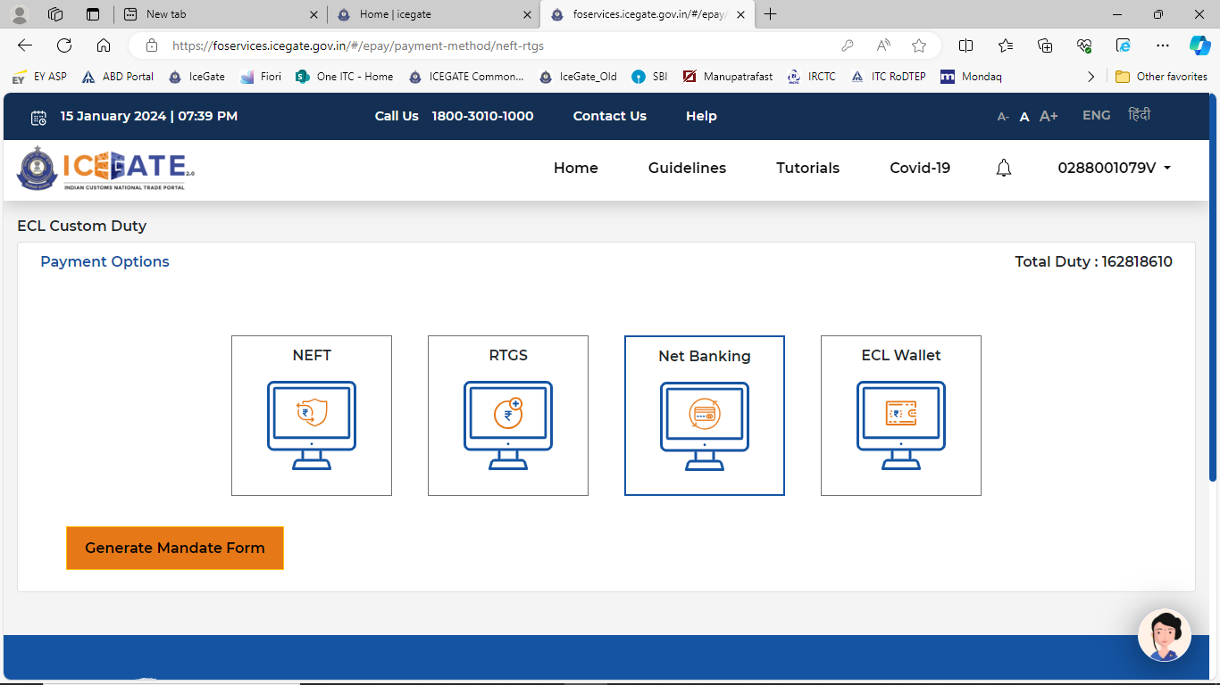

Select “SBI” and then click on “Make Payment”
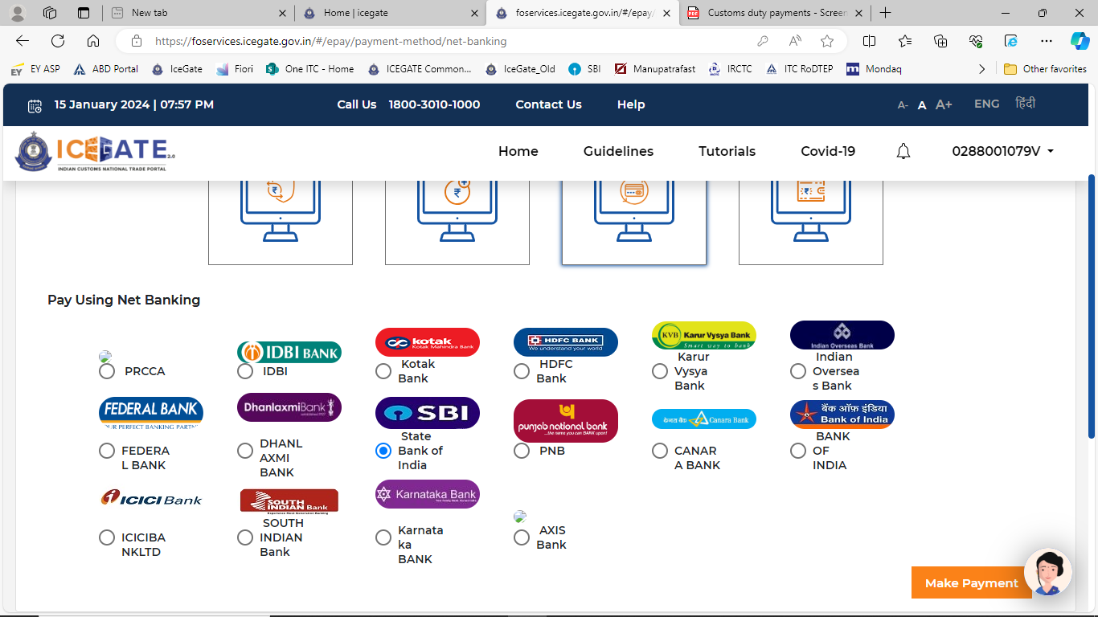
System opens another window with SBI net banking. Select “Corporate Banking”
Enter User ID and Password
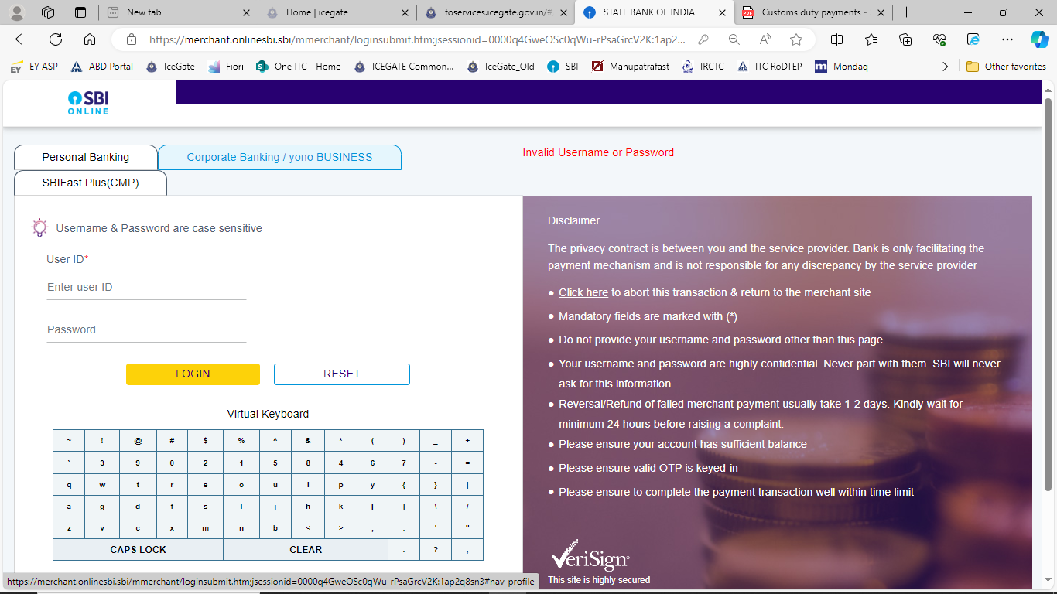

Select “payment without using merchant payment limit” and “submit”
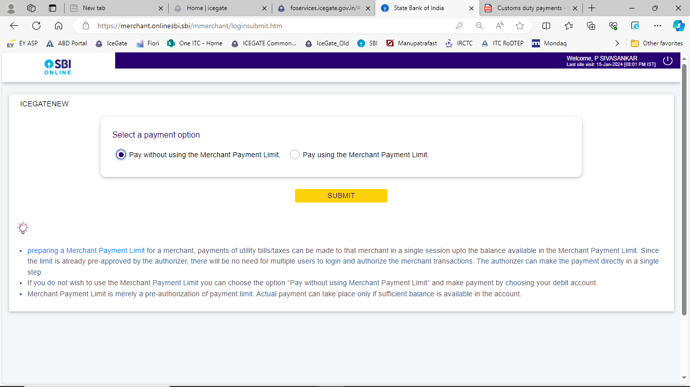
Capture the “IG Reference Number” into the RoDTEP system and select “Confirm”
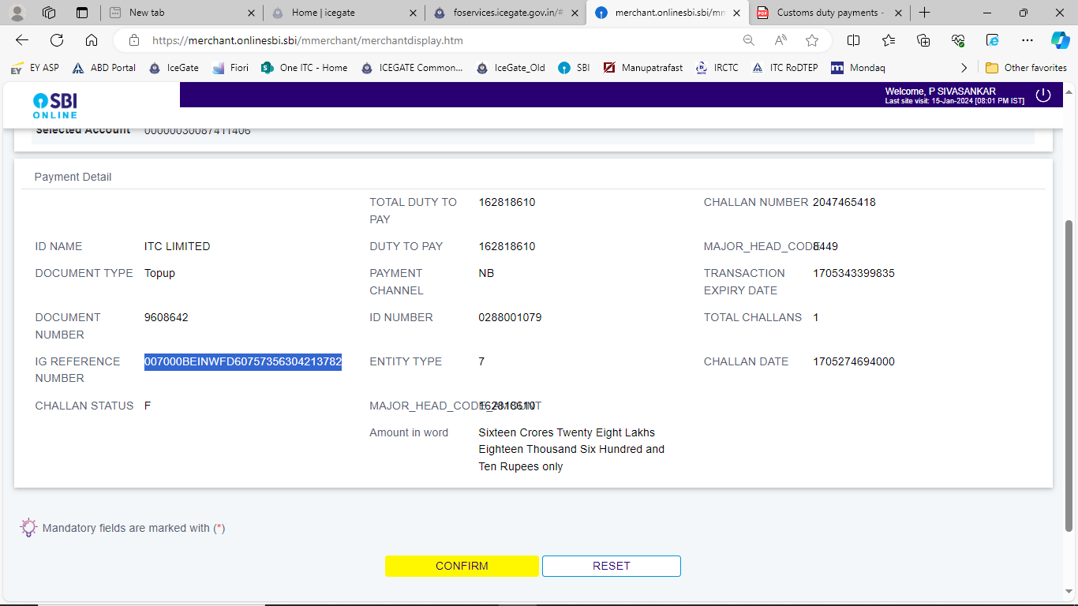

Enter OTP in “Enter High Security Password” section and press “Confirm”
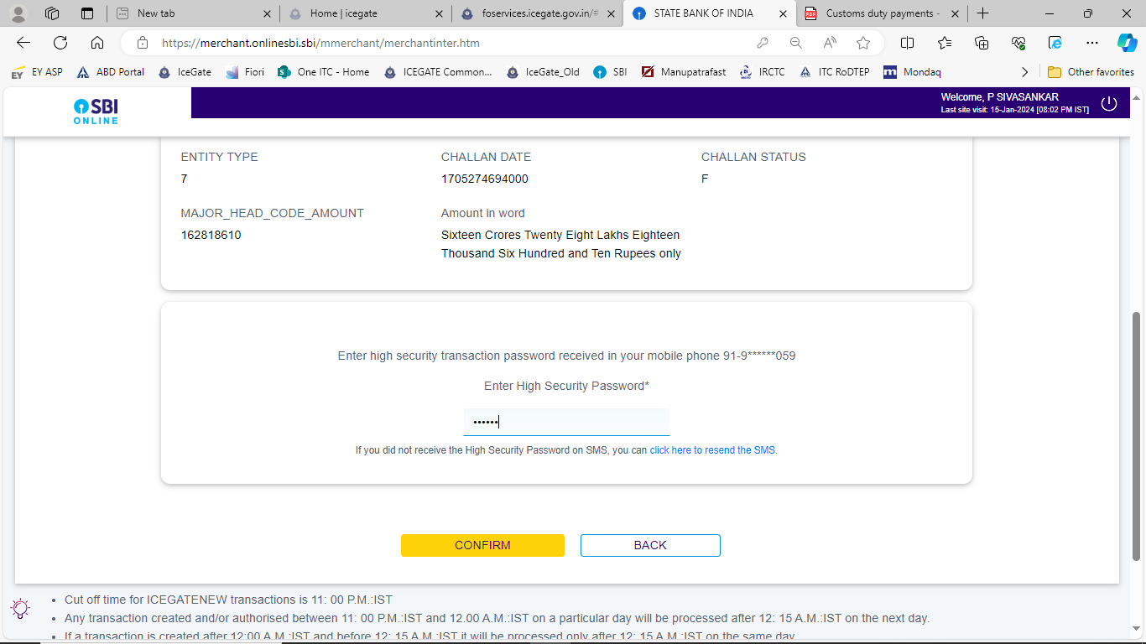
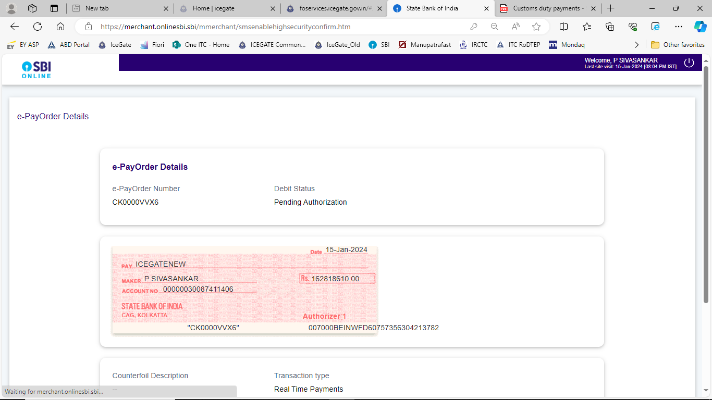
Capture “e-Payorder Number” into the RoDTEP system

