

Watchstationindia

Sold Out Changes

Requirements Specification
Revalsys

REVISION HISTORY:

Version | Date Modified | Author | Reason for Change
1.0 | 03 Apr 2025 | Syam Babu | 1. REV0024T294 – Current year adding in the request Jons for request and report names.

This document has been reviewed and accepted:
Version | Date Reviewed | Reviewer Name | Title
1.0

CONTENTS
CONTENTS 3
1. Introduction 4
1.1 Overview 4
1.2 Purpose 4
2. Scope 4
2.1 Scope Inclusion 4
3. Context Diagram (High –Level approach) 4
3.1 Current Context (in-case of re-engineering project) 4
3.2 Context diagram 4
4. Standards, Conventions and Procedures 4
4.1 Development Language 4
4.2 Design/Programming Standards/Naming Conventions 4
4.3 Authentication Mechanism 4
4.4 Exception Handling/Logging 4
4.4.1 Unhandled exception logging: 4
4.4.2 Handled exception logging. 4
4.4.3 General logging. 5
4.4.4 Displaying Error Messages to Users: 5
4.5 Session Management 5
4.6 Database Calls 5
4.7. Configuration Parameters 5
5. Framework Components 5
6. Database Schema 5
6.1 Stored Procedures 5
7. Business Components …………………………………………………………………………………………………………………………………. 5
8. Screen/ETL Design: 6

Introduction

Overview
- Previous Implementation (Static Year):
- In the previous design, the year used for maps report names and requests was static across all instances.
- The year was manually set, and no dynamic binding was in place.
- New Implementation (Dynamic Year Binding):
- In the updated design, the year is dynamically determined from the system’s current date.
- This is achieved by binding the current year from the Date object automatically.

Process Overview:

- Step 1: Calling the JSON Object:
- The JSON object (containing maps report names and requests) is called as part of the process.
- Step 2: Appending the Current Year:
- The current year is automatically appended to the year array within the request. This ensures that the request is always up to date with the current year.
- Step 3: Replacing Year in Strings:
  - If a placeholder like [#Year#] is found in the report name , it is dynamically replaced with the current year.
  - This replacement ensures that any report names or other strings that depend on the year will reflect the correct year value.

Key Benefits:
- Automation: The process eliminates the need for manual updates of the year, reducing human error and ensuring consistency.
- Flexibility: With dynamic year binding, the system automatically adapts to the current date without requiring code changes.
- Accuracy: The reports will always use the correct, up-to-date year without requiring intervention.

- Technical Flow:
- The system fetches the current date.
- Extracts the year from the date object.
- Binds and appends this year into the year array in the request JSON.
- If placeholders like [#Year#] exist, the system replaces them with the current year.
- Edge Case Handling:
- If no year is present in the JSON, the system will append the current year.
- If the year is already dynamically included, it will be replaced correctly without causing any redundancy.
- Conclusion:
- This dynamic year binding approach ensures that the reports and requests are always aligned with the current year without manual intervention, leading to more efficient and error-free processing.

- OverAllSales:
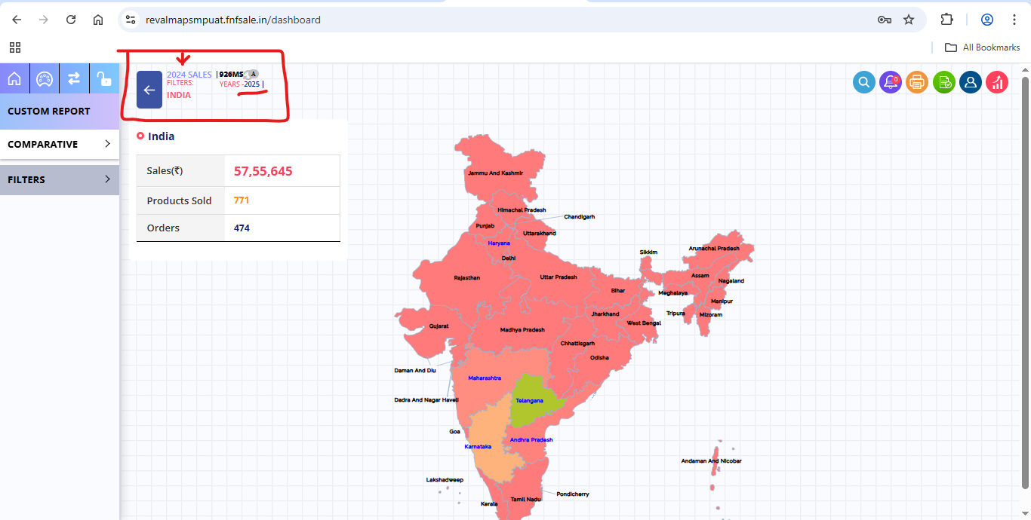

- Sales By Marketplace.
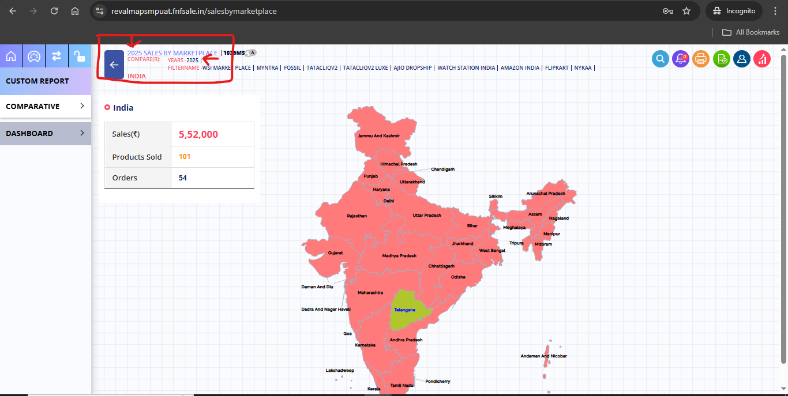

- Target Vs Actual.
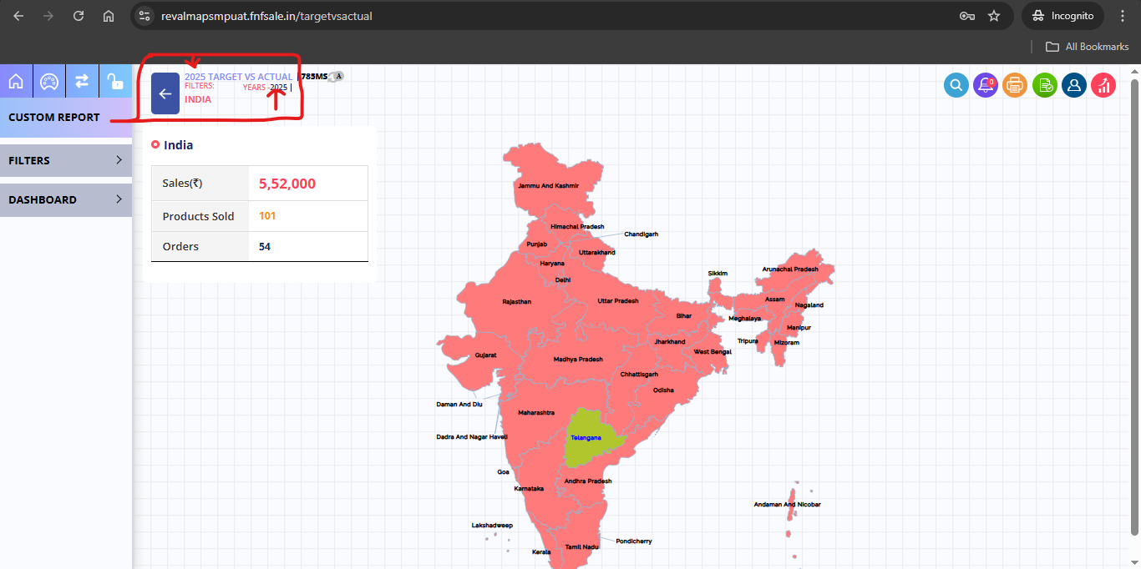

- Orders By Product.
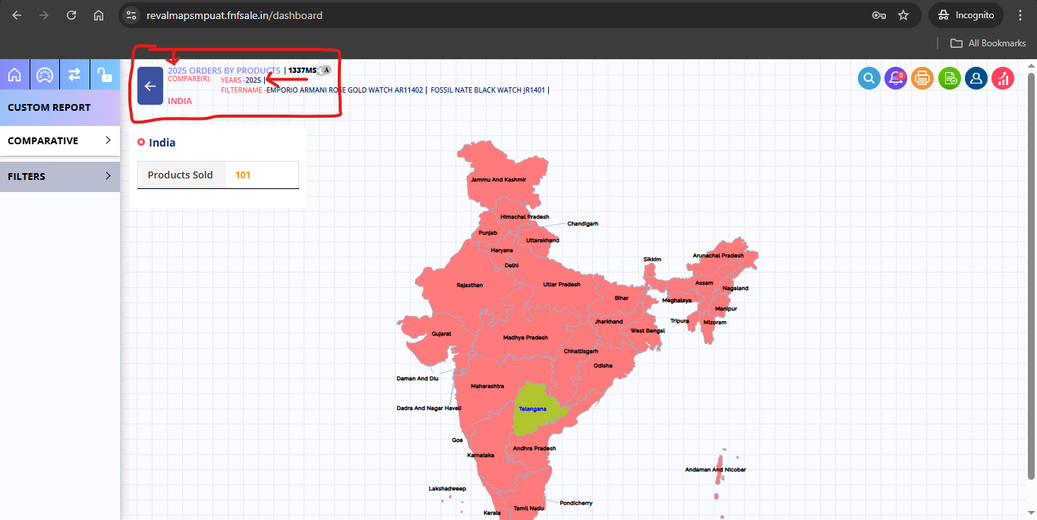

- Sales By Stores.
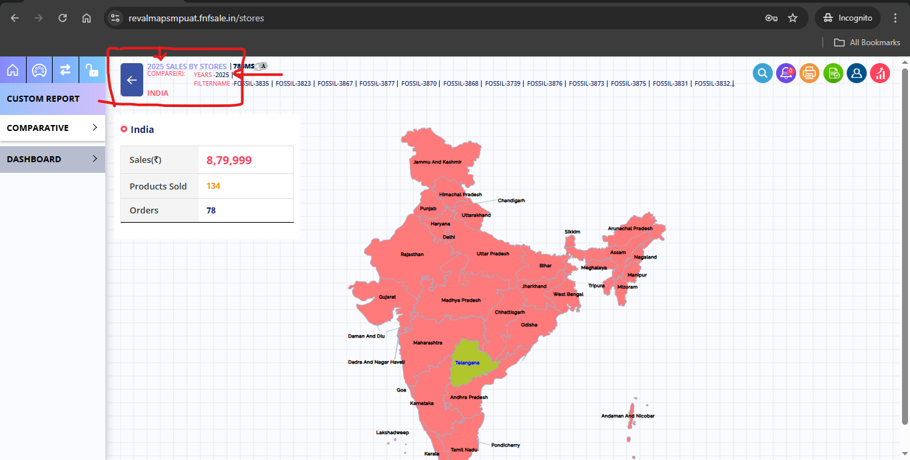

- ProductsV1: for product details in List.
URL | https://revalmapsmpapiuat.fnfsale.in/api/GetOrders
Type  Request | Post  {  "FilteredDates": {  "Dates": [],  "Months": [],  "Quarters": [],  "Years": [  2025  ]  },  "FilterType": "Y",  "CompareType": "",  "Levels": [  0  ],  "IsAllMarketPlaces": true,  "IsNextLevelNotExists": false,  "Facets": [],  "IsCompare": false,  "IsExtraFilter": 0,  "IsRegion": false,  "StoreOrderStatus": "1,2,3,4,5,6,7,9,10,11,12,13,14,15,16,17,18,19,20,21,22,23,24,25,26,27,28,29,30,31,32,34,35,36,37,38,39,40,41,42,43,44,45,46,47,48,49,50,51,52,53,54,55,56,57,58,59,60,61,62,63,64,65,66,67,68,69,70,71,72,73,74,75,76,77,78,79,80,81,82,83,84,85,86,87,88,89,90,91,92,93,94,95,96,97,98,99,100,101,102,103,104,105,106,107,108,109,110,111,112,113,114,115,116,117,118,119,120,121,122,123,124,125,126"  }
Response | {  "ReturnCode": 0,  "ReturnMessage": "Success.",  "ServerDate": "4/3/2025 2:58:19 PM",  "RowCount": 5,  "ResponseTime": "656",  "Data": {  "Response": [  {  "Id": 28,  "Name": "Andhra Pradesh",  "Sales": 215638,  "SalesCount": 18,  "ProductsSold": 20,  "AverageOrderValue": 11980,  "Percentile": 6,  "Dates": null  },  {  "Id": 6,  "Name": "Haryana",  "Sales": 7484,  "SalesCount": 1,  "ProductsSold": 2,  "AverageOrderValue": 7484,  "Percentile": 1,  "Dates": null  },  {  "Id": 29,  "Name": "Karnataka",  "Sales": 1245497,  "SalesCount": 59,  "ProductsSold": 143,  "AverageOrderValue": 21110,  "Percentile": 33,  "Dates": null  },  {  "Id": 27,  "Name": "Maharashtra",  "Sales": 466394.6,  "SalesCount": 37,  "ProductsSold": 43,  "AverageOrderValue": 12605,  "Percentile": 12,  "Dates": null  },  {  "Id": 36,  "Name": "TELANGANA",  "Sales": 3820631.9998,  "SalesCount": 359,  "ProductsSold": 563,  "AverageOrderValue": 10642,  "Percentile": 100,  "Dates": null  }  ],  "Assets": {  "ToolTipKeys": null,  "OverAllSales": 5755645.5998,  "OverAllProductsSold": 771,  "OverAllOrders": 474  }  }  }

